Project Title

Smart Clinic Appointment System

1. Project Overview
The Smart Clinic Booking System is a web-based healthcare management platform developed using Blazor (.NET), C#, and SQL Server. The system aims to digitize and streamline clinic operations from browsing doctors and checking symptoms to booking appointments and managing patient health records.
The platform supports three types of users: Patients, Doctors, and Administrators, each with dedicated dashboards and role-specific features. Patients can browse the system without logging in but must authenticate to book appointments or access personal health data.

Key Features:
- AI-powered Symptom Checker
- Visual Patient Health Timeline for complete medical history
- Digital Prescription System with printable prescription cards
- Role-Based Access Control (Admin, Doctor, Patient)
- Clean and modern user interface focused on usability

2. Problem Statement
Most local clinics still rely on manual or outdated systems for managing appointments and patient records. This leads to several issues:
- Patients cannot easily find doctors by specialty or location
- Appointment scheduling via phone causes confusion and missed bookings
- No centralized record for patient history, diagnoses, or prescriptions
- Doctors lack digital tools for managing schedules and prescriptions
- Patients often visit the wrong specialist due to lack of guidance
- Administrators have no analytical tools for performance tracking
These inefficiencies waste time, increase errors, and reduce the quality of healthcare services.

3. Proposed Solution
The proposed system addresses these issues through the following modules:

3.1 Doctor Discovery
Patients can search and filter doctors by specialty, rating, and availability without visiting or calling the clinic.

3.2 Online Appointment Booking
Authenticated patients can view available time slots and book appointments in real time. All bookings are instantly recorded and visible to both doctors and patients.

3.3 AI Symptom Checker
Patients can input symptoms and receive recommendations on the type of doctor to consult, urgency level, and basic advice.

3.4 Patient Health Timeline
A visual timeline displays all visits, diagnoses, and prescriptions, helping both patients and doctors understand medical history clearly.

3.5 Digital Prescription
Doctors can issue digital prescriptions that patients can view, download, or print anytime.

3.6 Role-Based Dashboards
Each user (Patient, Doctor, Admin) gets a customized dashboard with relevant features and tools.

4. System Modules
Module | Description | User Role
Authentication & Authorization | Secure login and role-based access control | All Users
Doctor Listing & Profile | Search and filter doctors | Public
AI Symptom Checker | Get doctor recommendations based on symptoms | Public / Patient
Appointment Booking | Book appointments with doctors | Patient
Patient Dashboard | View appointments and health summary | Patient
Health Timeline | Visual record of medical history | Patient
Digital Prescription | Issue and view prescriptions | Doctor / Patient
Doctor Dashboard | Manage schedule and appointments | Doctor
Admin Dashboard | Manage users and view analytics | Admin

5. Technologies Used
Category | Technology
Frontend Framework | Blazor Server (.NET)
Programming Language | C#
Markup & Styling | HTML5, CSS3, Bootstrap 5
Client Interactivity | JavaScript
Database | SQL Server
ORM | Entity Framework Core
Authentication | ASP.NET Core Identity

6. Visual Mockups
Used Figma for mockups
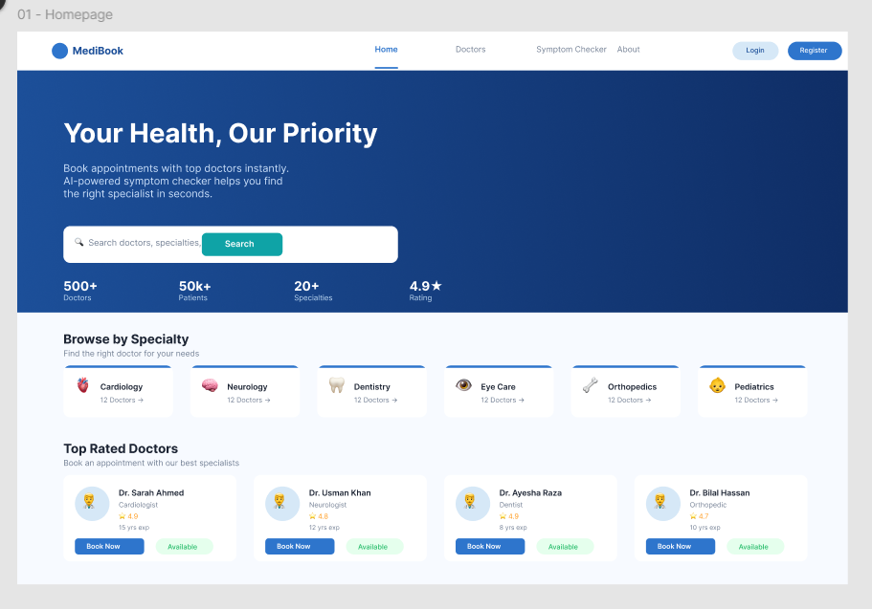
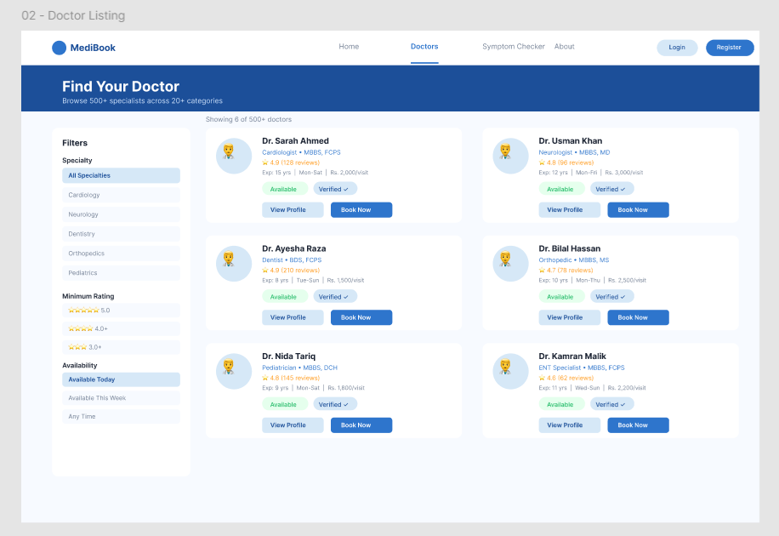
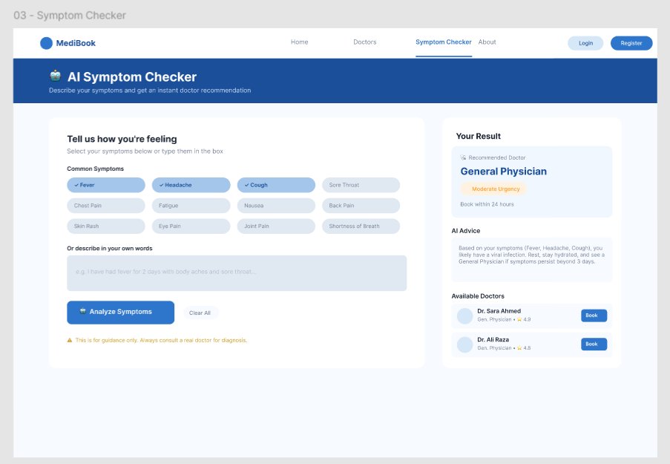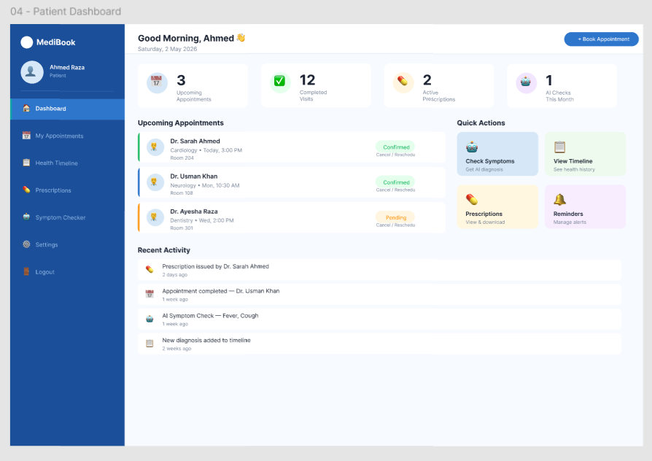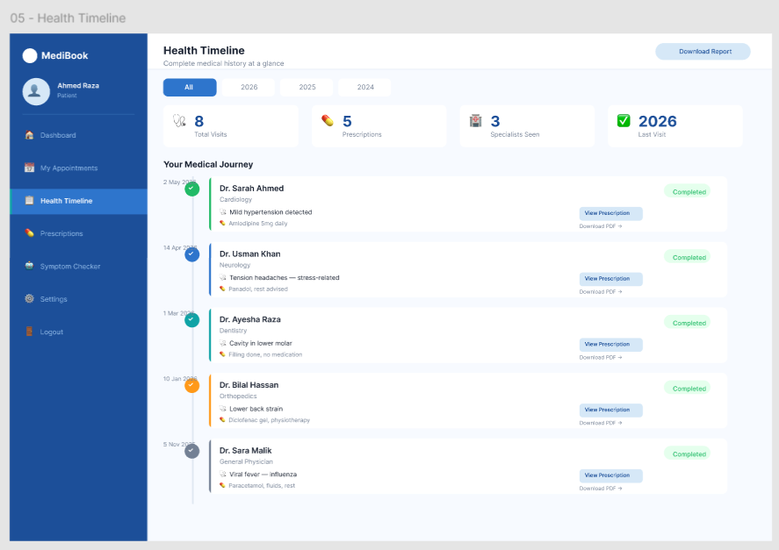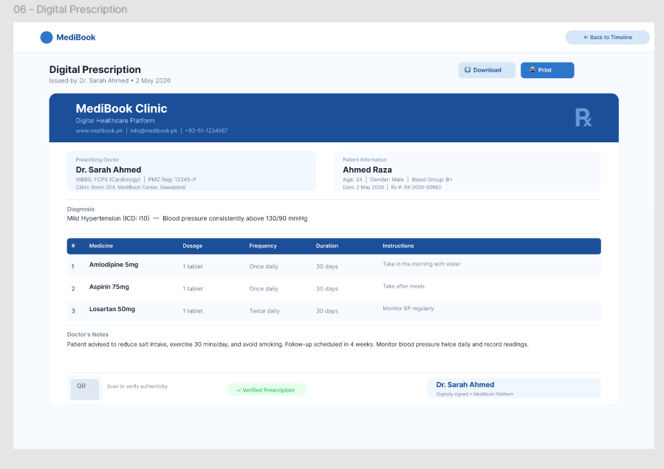

o Reports or Output Screens

7. Conclusion
The Smart Clinic Booking System is a comprehensive web application that demonstrates the practical implementation of modern development technologies taught in the Visual Programming course.
It addresses real-world healthcare challenges such as inefficient appointment systems, lack of digital records, and difficulty in finding the right doctor. By integrating AI, role-based security, and a user-friendly interface, the system delivers both technical depth and real-world value.
The goal is to deliver a polished, fully functional application that reflects both strong technical skills and thoughtful system design.

